**Week02 - Creating a Database in MySQL workbench**

1. Enter the entities into workbench as an EER Diagram

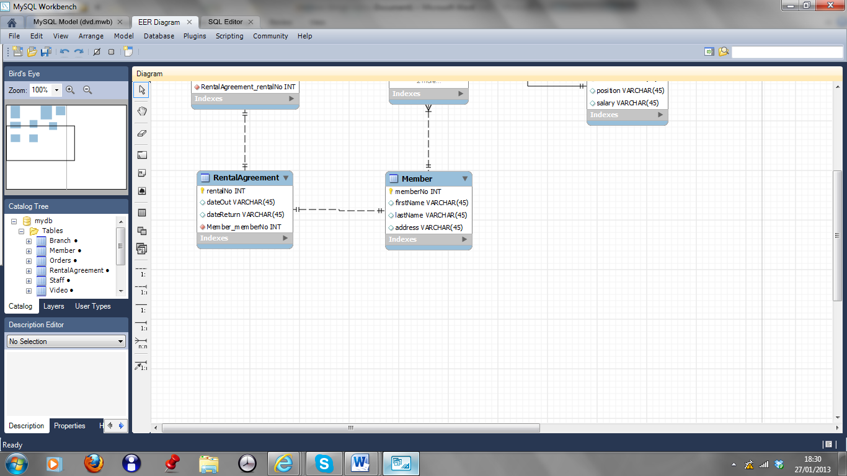

Figure01: EER Diagram complete on workbench

Select Database from menu, then forward engineer.. (as shown)

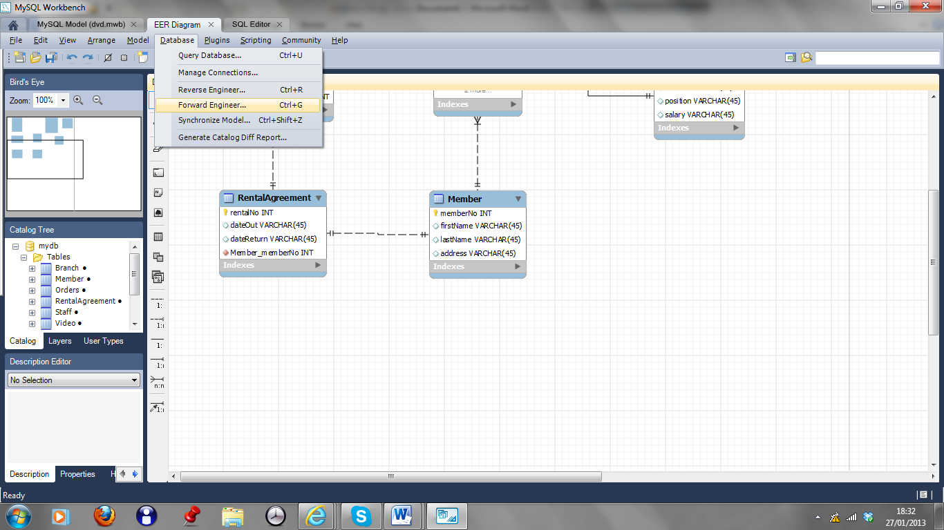

1. Go through the menus…select next..next…next etc

If the design goes through with no problems…select Database…Query Database

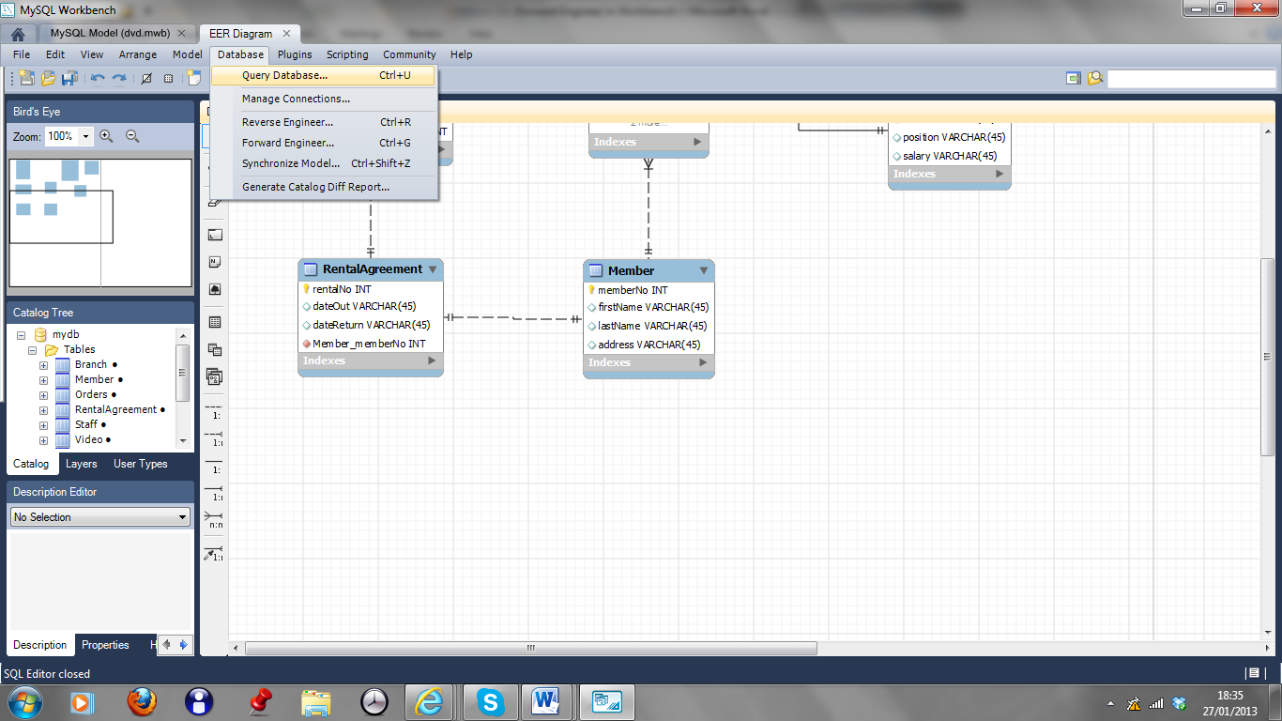

Menu appears…click on OK

1. You are now in the database itself, select the schema from the left-hand pane, it will reveal the tables and you will be able to see the entire system.